Front End Developer Challenge

So you think you have what it takes to be a Front End Developer with Aquent IT Solutions? Complete the exercise below and post it somewhere for us to see.

“You have been asked to create a directory page for the UX Society website. We have provided a service to retrieve data about the members. Create a directory that runs off the service, provides a quick search and the ability to click for more details about a member. We have provided a quick mock-up of the screen as a guideline”

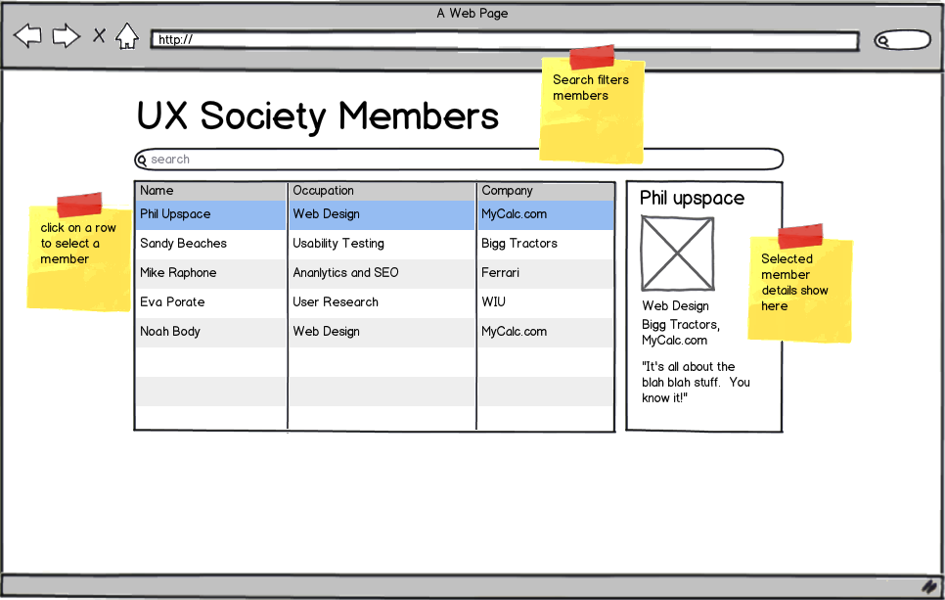

The service for the data is available at:

http://private-a73e-aquentuxsociety.apiary-mock.com/members

What we expect:

Complete this exercise using AngularJS. Make it look presentable as well. We like bootstrap, but any sort of CSS will do. Post your project on GitHub and send us the link at [bmangan@aquent.com](mailto:bmangan@aquent.com).

If you have no idea where to start and would like to get some guidance, reach out to Mark at [mhein@aquent.com](mailto:mhein@aquent.com).